**Introduction:**

In this project, we have used MQ2 for detecting the gas leakage in the kitchen and some other LPG used factories.

**Hardware Required**

* Arduino Uno with USB Cable – 1
* MQ2 gas sensor -1
* Buzzer B10-1
* 9v Battery with DC jack -1
* Breadboard 830 pt -1
* Jumper wire (Male to Male )- 18 pcs

**Specification**

**4 digit 7 segment**

A 7 segment LED display consists of 7 LEDs arranged in such a way that it can display numbers from 0 to 9. The arrangement of LEDs in the display can be either common anode or common cathode.

In this project, a 4 – digit 7 – segment LED display is used to display numbers using Arduino.

Either a compact module containing four 7- segment LED displays can be used or four individual 7 – segment displays can be used by multiplexing them.

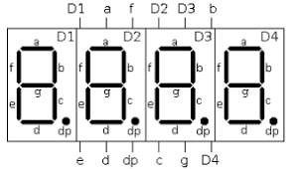

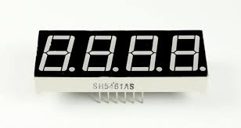

**MQ2 gas sensor**

The Grove - Gas Sensor(MQ2) module is useful for gas leakage detection (home and industry). It is suitable for detecting H2, LPG, CH4, CO, Alcohol, Smoke or Propane. Due to its high sensitivity and fast response time, measurement can be taken as soon as possible. The sensitivity of the sensor can be adjusted by potentiometer.

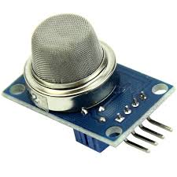

**Circuit Connection**

* Connect 2 GND pins of Arduino Uno with buzzer and MQ2 gas sensor.
* Connect Pin 5V of Arduino Uno with 5V power supply of MQ2 gas sensor.
* Connect input pin of MQ2 with A5 of arduino uno.
* Connect VCC of buzzer with 13 pin of arduino.
* Connect 1,2,4,5 pin of 4 digit 7 segment display to the 6,5,4,3 pin of arduino uno respectively.
* Connect Pin 6 of 4 digit 7 segment display to a 220 ohm resistance which is further connected to 2 pin of the arduino uno.
* Connect pin 7,10,11 of 4 digit 7 segment display to the 7,10, 11 of arduino uno respectively.
* Connect Pin 8,9 and 12 of 4 digit 7 segment display to 220 ohm resistance each individually and further connect the resistance to the 8,9,and 12 pin of arduino uno.

**Working and Output**

This project is all about detecting gas content in atmosphere and displaying it in 4 digit 7 segment display. In this the MQ2 gas detector

detects the gas content in the atmosphere i.e. the amount of LPG or propane and some other gases in the atmosphere. After that the data (amount of gas content) is sent to the 4 digit 7 segment display which shows the amount of gas content. There is a buzzer also which turns on as the amount of gas is high in atmosphere.

**Code& Library**

Before uploading the code, Must install this library:

Servo Master is inbuilt Library or you candownload it from <https://drive.google.com/open?id=1XEyFZik_ENYtE4LOf3mOP3kqfqH3FNh2>

**Library**

<https://drive.google.com/open?id=1Gv4l6H76nWt07tUEJO_E0J181nh1r2rO>